Count me in to help Harpenden Mencap
No information about you will be shared and will only be used to process your donation or communications in accordance with your selection. For a full copy of Harpenden Mencap’s Privacy statement please visit www.harpendenmencap.org.uk. You can withdraw consent at any time by emailing dataprotection@harpendenmencap.co.uk

Harpenden Mencap has been providing services to people with learning disabilities since 1959. We are a local self-funded organisation and need support to help the work we do.
Personal Details: | Mr Mrs Mr & Mrs Miss Ms  First Name: ___________________ Family Name: _____________________  Address: _____________________________________________________________  Post code: ________________ Email Address: ______________________________  phone: (home) ________________________ (mobile) _______________________
What for and/or legacy: | - Please use my donation where it is most needed  - I would like to use it for a specific purpose – contact me for details  - I wish to leave a gift in my will to benefit Harpenden Mencap – contact me for details
Payment details:  Your generous contribution and support is needed more than ever | - I have enclosed my cheque payable to Harpenden Mencap  - Please charge my debit/credit card:  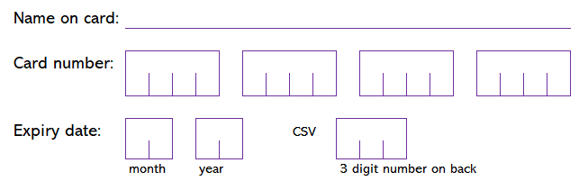
 | *If you would like to setup a monthly, annual or any other regular standing order, please phone 01582 460055 for details.
Gift Aid Declaration:  By allowing Harpenden Mencap to treat this donation as a Gift Aid donation you enable the charity to reclaim extra money from HMRC | - By ticking this box I confirm that I am a UK taxpayer and would like to add Gift Aid to all my donations to Harpenden Mencap, past present and future. I understand I must pay enough Income Tax and/or Capital Gains Tax each year to cover the amount of Gift Aid that all charities claim on my donations. I shall let you know if my tax status, name or address change or I wish to cancel this declaration.
GDPR consent:  Whilst you’re here, whether or not you are making a donation, please confirm your details if you would like us to stay in touch | - Please tick this box if you would like to be informed about what we are doing, news and forthcoming events:  Name (if not above) ________________________________________
 | - by email: ________________________________________________
 | - by phone: (home) ________________ (mobile) ________________
- by post:

No information about you will be shared and will only be used to process your donation or communications in accordance with your selection. For a full copy of Harpenden Mencap’s Privacy statement please visit www.harpendenmencap.org.uk. You can withdraw consent at any time by emailing dataprotection@harpendenmencap.co.uk
Our contact details: | Harpenden Mencap 19 Douglas Road Harpenden AL5 2EN Tel: 01582 460055 Web: www.harpendenmencap.org.uk  Email: office@harpendenmencap.co.uk  Registered charity number: 1035252  Company number: 02903642

